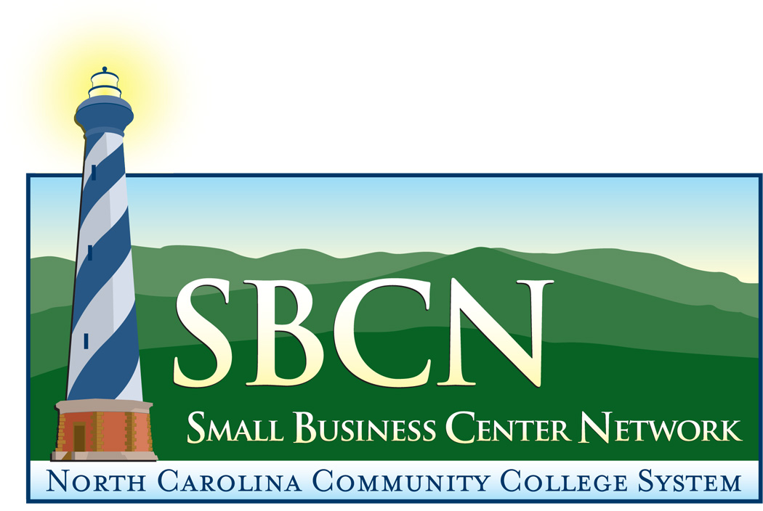
Business Organization Structure
Choosing the organization structure of your business is an important decision. Therefore, the advice of an attorney can be especially valuable. The organization selected should be based not only on the immediate needs of the business but what is anticipated for the future. The form of business is also important from a tax and personal liability standpoint. The three principal forms of business structure are the sole proprietorship, the partnership, and the corporation. LLC and Sub-Chapter S are varieties of a corporation.

Refer to the table below for characteristics, advantages and disadvantages for each.

 |  | Business Structures-Advantages & Disadvantages |  |  |  |  | As of 10/13/09
Preferred Business Structure | Sole Proprietor |  | Partnership | Corporation (S or C) |  | Limited Liability Company
Tolerance for Liability | Sole-owner business where taxes or product liability are not a concern |  | Business with one or more people where taxes or product liability are not a concern | Sole or multiple-owner business where owner(s) need company-funded fringe benefits and liability protection |  | Sole or multiple-owner business where owner(s) need limited liability but want to be taxed as a partnership
Number of Owners | One |  | Two or more to be classified as a partnership | 1-75 for S Corp;  More than 1 for C Corp |  | One or more (initially, and can be classified as a partnership)
Type of Owners | Individual |  | Any | S Corp limited to U.S. residents and citizens and to certain trusts/estate;  Any for C Corp |  | Any
Attributes of Entity | Inseparable from owner |  | Inseparable from owner but can have debt or property in its name | Separate legal entity |  | Separate legal entity
Major Advantages | Inexpensive to form. Few administrative duties |  | Inexpensive to form. Few administrative duties | Limited liability. Capital is easy to raise through sale of stock. Company-paid fringe benefits (C only). Tax savings through income splitting (C only) |  | Limited liability as a corporation. Capital is easy to raise through sale of interests. Pass-through taxation like a partnership. Unlimited number of owners
Major Disadvantages | No tax benefits. Unlimited liability. Business dissolves upon death of owner |  | No tax benefits. Unlimited liability, also liable for partners’ acts. Legally dissolves upon death or change of a partner | Can be costly to form. More administrative duties. S Corp must have fewer than 100 shareholders |  | Can be costly to form. More administrative duties
Liability and Tax Reporting | Owner is responsible. File Schedule C with form 1040 |  | Partners are responsible. File form 1065 | C Corp pays taxes and files form 1120. S Corp passes taxes thru to owner and files 1120S |  | Deductibility of Losses
Deductibility of Losses | Losses may be used by owner subject to passive loss rules |  | Partnership losses passed thru to partners subject to at-risk rules and passive loss rules | Do not pass thru to shareholders (C Corp). Passed thru to shareholders subject to at-risk rules for S Corp |  | Same as partnership
Choice of Fiscal Year | Calendar year |  | Must be same as principal partners unless IRS consents | No restrictions for C Corp. S Corp must use calendar year or show a business reason for other fiscal period |  | Same as partnership
Cost of Formation | Nominal |  | None for general partnership. $50 filing fee for limited partnership | $250 filing fee.  $20 annual report fee (online); $25 (hard copy) |  | $250 filing fee  $200 annual report fee (minimum)
How Register | County Register of Deeds |  | County Register of Deeds | Secretary of State and County Register of Deeds |  | Secretary of State and County Register of  Deeds

